DISTRIBUTION OF COVID -19 SUPPLIES
Support is provided to schools to build their readiness for reopening and help teachers and learners feel safe to return to schools and resume their work. Through the funds from Global Partnership for Education, the Ministry of Primary and Secondary Education is being supported with COVID -19 supplies which includes protective equipment such as mask and hygiene kits.

The distribution of the COVID -19 supplies to 3733 schools is underway. The targeted schools are: 1000 primary registered P3 schools, 800 secondary registered S3 schools, 32 special schools, 1051 primary satellite schools and 850 secondary satellite schools.
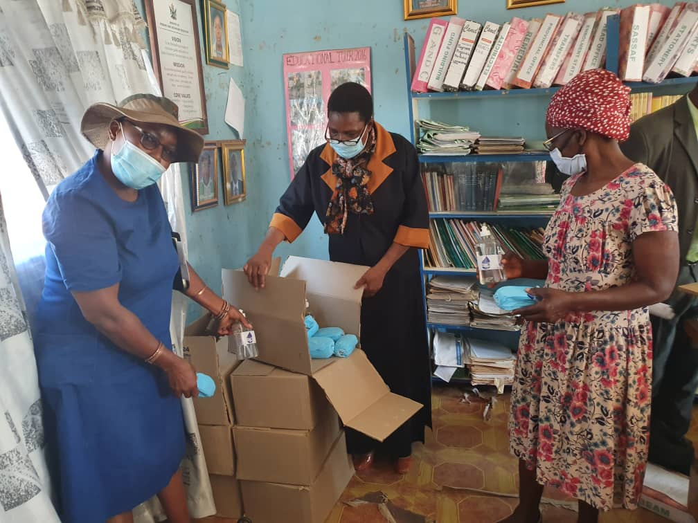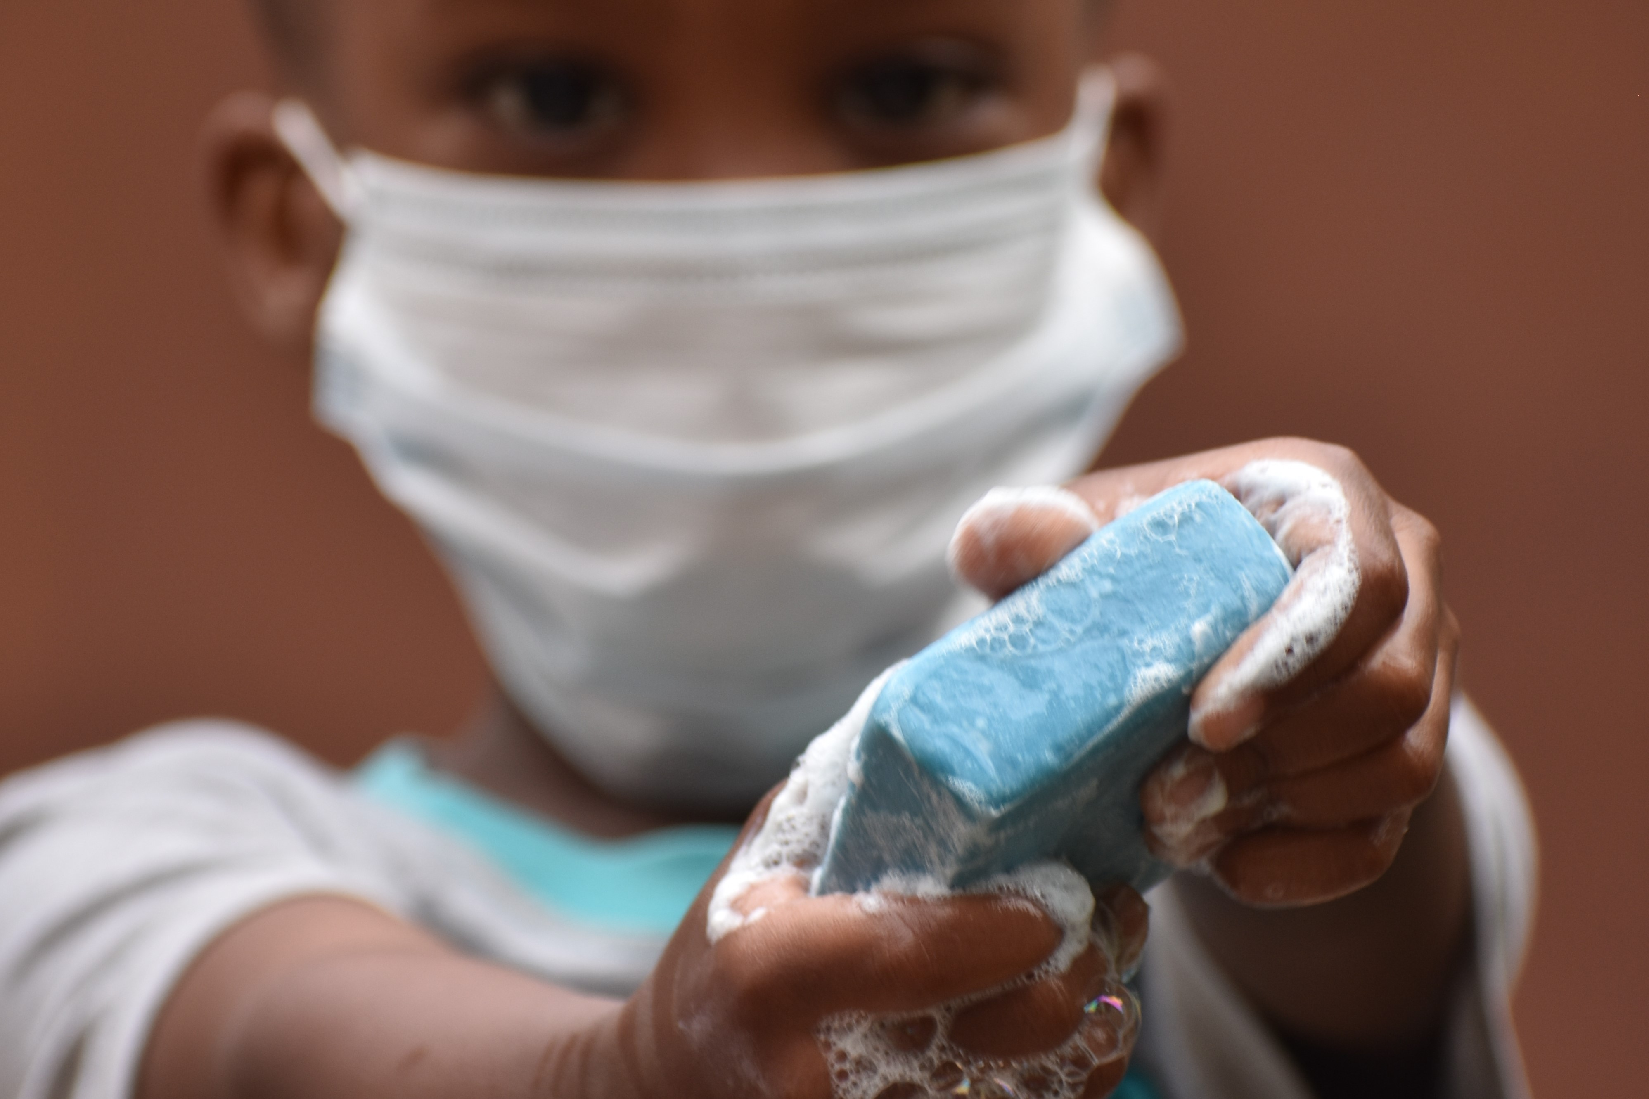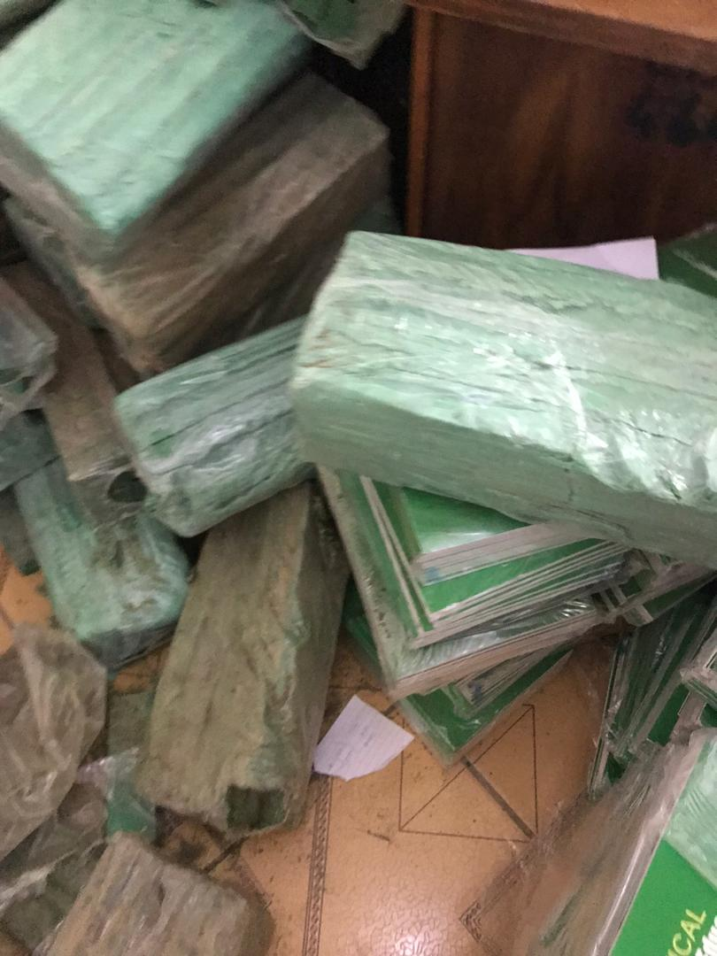
Photo left: Schools have started receiving PPE in preparation for reopening on the 28th of September. Ministry of Primary and Secondary Education’s Permanent Secretary Mrs T. Thabela was shown some of the PPE at Magunje Primary School in UMP. Photo centre: With the support of Global Partnership for Education, UNICEF is assisting MoPSE to distribute 20,000 reusable masks for use for teachers and education officials. Photo extreme right: Soap, face masks and inclusive education handbook distributed at Mwenezi District offices.
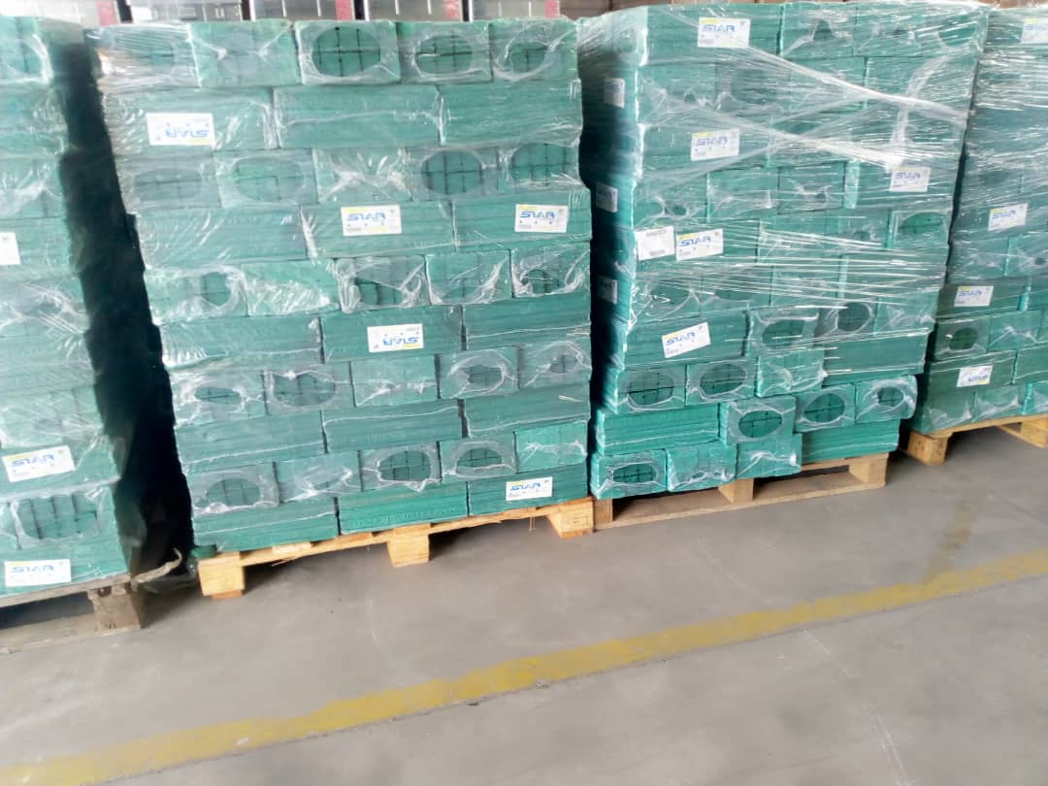
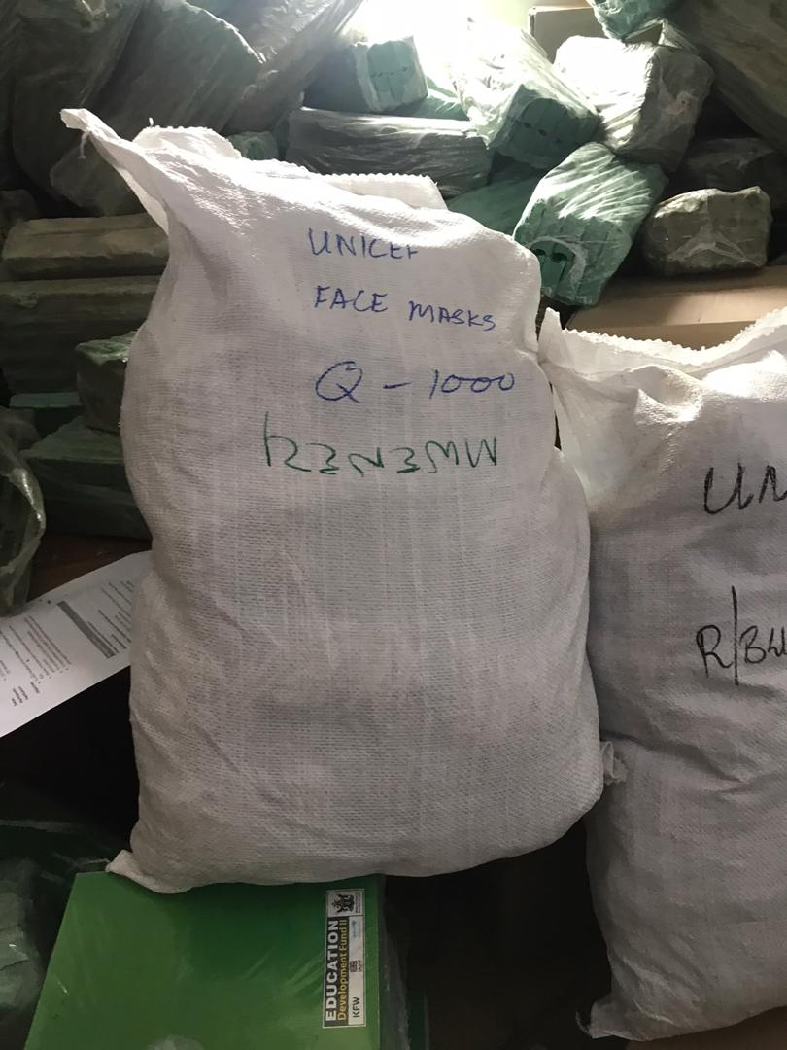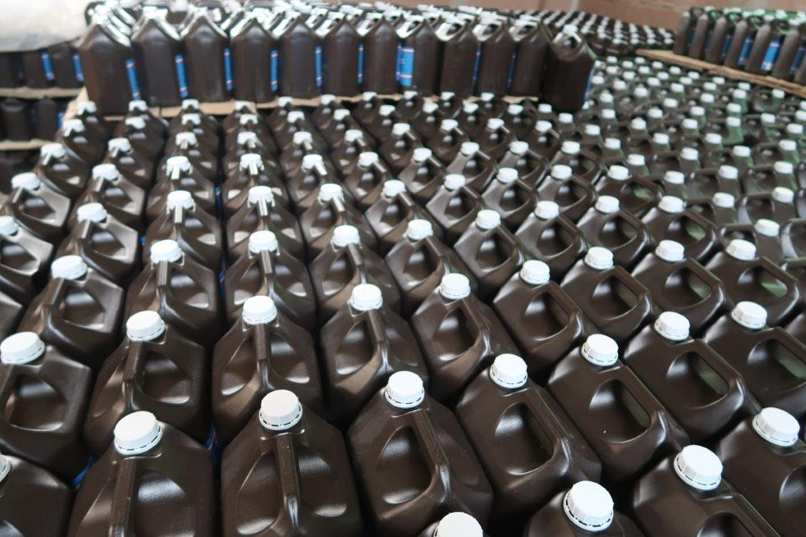
Photo above and left: Soaps and reusabe face masks for hygiene kits waiting to be loaded to trucks for distribution. Photo bottom right : Chlorine solution 5l containers as part of hygiene kit to be distributed.
The hygiene kit which is a part of the COVID -19 supplies comprise:
- Water treatment tablets
- handwashing facilities (bucket pus stand)
- face masks
- non-contact thermometers
- Soap toilet bar.
- Liquid soap for handwashing
- Alcohol- based sanitizer
- Lightweight plastic bucket for cleaning latrines
- Bucket with taps for drinking water
- Gumboots; gloves
- PVC, overalls
- Rubber broom/floor squeegee and soft and hard brooms
- Chlorine solution liquid
- Toilet brush
- Knapsack sprayer (Backpack).

