Alternate Learning – Radio Lessons
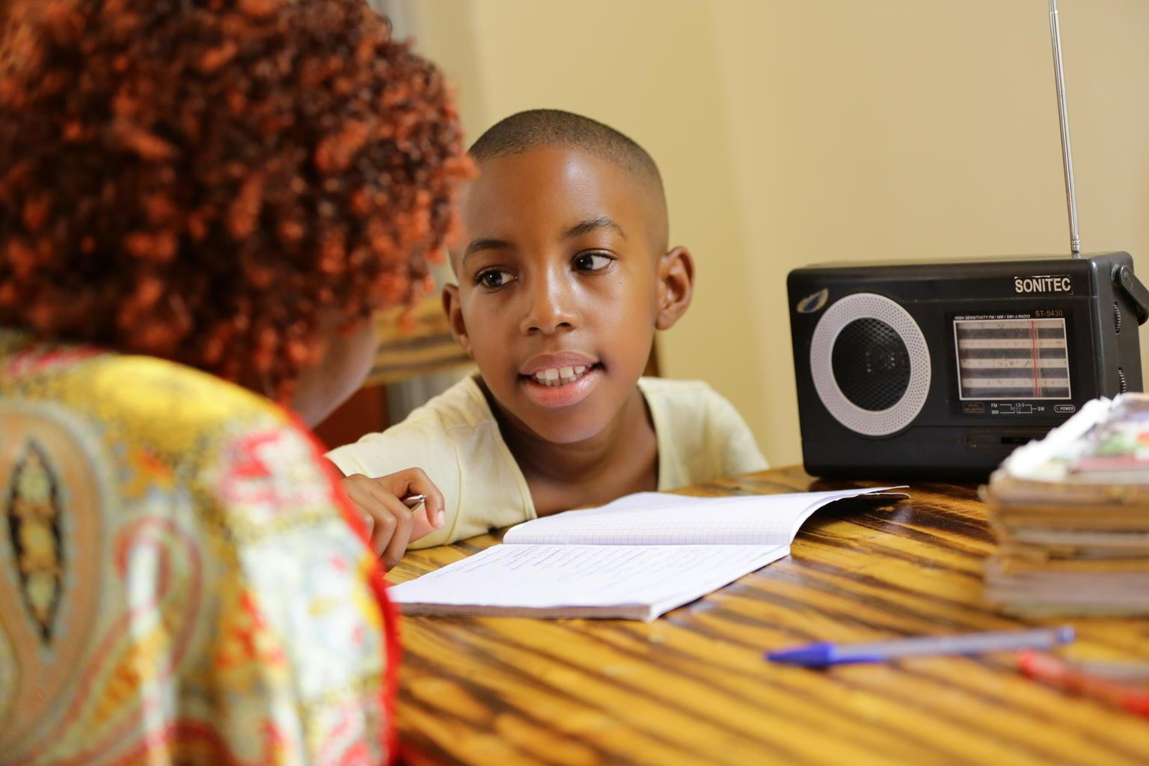
Image source: UNICEF Zimbabwe
The Ministry of Primary and Secondary Education with the support of UNICEF launched radio lessons to help learners continue with their education while schools are closed due to COVID -19 pandemic. The broadcasting of lessons commenced on 16 June 2020.
The lessons covering primary school grades from ECD to Grade 7 are being broadcast by Zimbabwe Broadcasting Corporation (ZBC) through five radio stations. Infant school lessons (ECD to Grade 2) are being broadcast on National FM while junior school lessons (Grade 3 to 7) are being broadcast on Power FM/Classic 263/Radio Zimbabwe/Khulumani FM, respectively. Schedules for lessons covering two-week durations are published by the MoPSE. The radio lessons broadcasts have completed its 14th week of broadcasting.
The United Nations Populations Fund (UNFPA) has been supporting the Ministry in Guidance and Counselling lessons.
On 21 September 2020, the Ministry in conjunction with ZBC and UNICEF rolled its first phase of indigenous radio lessons largely through community radio stations as part of alternative learning platform.
The broadcasting radio channels are: Star FM, Nyaminyami FM, Khulumani FM, Diamond FM and Hevoi FM.
The indigenous languages in which radio lessons are broadcast include: IsiNdebele, Shona, IsiXhosa, Nambya, Sotho, Kalanga, Venda, Chewa, Ndau, Tonga, Barwe, and Xangani.
Update as of 31 December 2020:
The Ministry, through a dedicated technical team of teachers and officers from Head Office coordinated by CDTS, is developing, and recording lessons for broadcast by the radio stations indicated above. As of 31 December 2020 1257 lessons (all Primary school level) had been developed, recorded and broadcast on the various radio stations but largely through ZBC. Number of lessons broadcast per week were reduced when all learners returned back to school.
Plans are also afoot for the commencement of television lessons in due course. In order to increase access to listenership, 3000 radio sets are being procured with support from UNICEF to be distributed to disadvantaged communities where learners have no access to radios.

